What is OMERO?

OMERO is a software platform for visualizing, managing, and annotating scientific image data. OMERO lets you import and archive your images, annotate and tag them, record your experimental protocols, and export images in a number of formats. It also allows you to collaborate with colleagues by creating user groups with different permission levels. Finally, it provides a convenient interface for programmatic access to your image data.

OMERO.web is a web-based interface that provides most of the core OMERO functions described above. You can explore the public JAX instance of OMERO.web at images.jax.org, where we have made some data publicly available. Note that this website is just a viewer for our public data and will not allow you to log in.

How can I work with image data stored in OMERO?

There are several options for working with image data in OMERO:

* The web interface available at omeroweb.jax.org can be used to view and annotate images and create figures.
* The OMERO plugin for Fiji/ImageJ allows you to directly interface your Fiji workflows with OMERO and save results back to the server easily.
* If you prefer to code your own solutions, OMERO also has interfaces with Python, Java, R, CellProfiler, and other analysis platforms. By using OMERO, you never need to worry about manually downloading data before running your analysis algorithms.

Is my data private? Can I see other people’s data?

By default, your data will not be seen outside of your group (e.g., lab). Each group owner (e.g., PI) can choose the set of permissions for their group. These range from private (each user only sees their own data, PI can see the whole group’s data) to read-write (everyone can do everything to each other’s data inside the group, including deletion).

How can I get started?

To be able to store your images in OMERO, you’ll have to request access via the Service Portal. Fill out an [Omero Access](https://jax.service-now.com/jax?id=sc_cat_item&sys_id=0ff8f9b5db5f9450b2d52eda489619b3) request ticket, which can also be found by searching for OMERO in the service catalog.

Once you have access to OMERO, you can log in to our internal, research instance at [omeroweb.jax.org](http://omeroweb.jax.org/) using your JAX “shortname” and password.

Follow the instructions below or the [online knowledge articles](https://jax.service-now.com/jax?id=kb_article&sys_id=7ad62d9547679d90f59b7351e36d43b4) to get started using OMERO. If you have questions or comments, contact JAX’s [Research IT Imaging Applications](https://jacksonlaboratory.sharepoint.com/sites/ResearchIT/SitePages/Imaging-Applications.aspx) team.

How do I import image data to OMERO?

JAX uses a special workflow for importing data into OMERO. Instead of relying on users to upload their own data directly to the server, we only require them to place their data into a specific folder, and the OMERO admins do the import. This is both due to an established minimum requirement for metadata and due to specificities on how we manage storage for the OMERO server.

From a user standpoint, the process is simple:

1. Map the path *\\jax.org\jax\omero-drop\dropbox* on your computer.

* On Windows, use *map network drive* from *This PC* with the above path

* On Mac, open Finder, then click *Go -> Connect* to server and use *smb://jax.org/jax/omero-drop/dropbox*.

2. Create a folder with a name following the convention shortname_YYYYMMDD (so, for me on 01/18/2021, that would be ratame_20210118).

3. Place your data inside that folder, together with a copy of the [import spreadsheet template](https://jax.service-now.com/sys_attachment.do?sys_id=fe61777d1b05159020caff39cc4bcb5b) filled in for your submission.

* Use one row per file you are uploading; add as much metadata as you want.
* Note that matches need to be exact:
  + “OMERO user” needs to be your short username (all lowercase)
  + “OMERO group” needs to match the group name you are uploading to (case-sensitive)
  + The “filename” column needs to match the filenames of the files in the folder (including extensions)

4. (optional) Let us know there is a new batch of files to be imported into OMERO. This can be a simple email or Slack message.

How do I use the OMERO web interface?

Logging into OMERO.web

You can log into OMERO by navigating to [omeroweb.jax.org](http://omeroweb.jax.org/). You will be taken to the Public User view. From there, click the *Login* button in the upper right corner of the screen (highlighted with a red box in the image below).

From the login screen, enter your JAX credentials. Note: you will need to use your “short” username, not your full email address (see below).

Browsing images in OMERO.web

Once you are logged in, you will be taken to the data view (see image below), which is broken into a navigation pane on the left, a thumbnail pane in the middle, and a metadata pane on the right.

Images are organized into Project and Datasets, which can be explored via the navigation pane on the left. Note that you only see data for the current group and user, which can be selected using the dropdown menu in the upper left.

Images can be selected directly via the navigation pane, or via the thumbnail pane in the middle. Once an image is selected, you will be able to view its associated metadata in the pane on the right. Metadata views are also available for Project and Datasets.

Viewing image detail

Our instance of OMERO.web has two different viewers that can be used to take a closer look at your images. To use the default viewer, simply double-click the image in which you are interested. However, we recommend using OMERO.iviewer, which has a nicer look in addition to a number of basic annotation and analysis tools. To use OMERO.iviewer, click on the *Open with...* button near the top of the metadata pane (see the red box in the image below).

Images can be opened with either the default viewer or OMERO.iviewer (recommended). The OMERO.iviewer is shown below.

Bulk-edit rendering settings in OMERO

When OMERO imports an image, image rendering settings will be automatically set depending on image type. This is not always desirable behavior. For example, OMERO may render images such that the minimum and maximum pixel values are rendered at minimum and maximum levels on your display, when you may want to consider the full range of possible pixel values. This is especially problematic for RGB TIF images, where automatically setting the rendering for each color channel independently can lead to distorted colors and interfere with biological interpretation.

Fortunately, it is easy to correct OMERO's rendering settings using OMERO.web!

Step 1: Navigate to a Dataset containing images with problematic rendering settings, then click on the *Preview* tab on the right panel.

Step 2: Examine the rendering settings in the *Preview* pane to identify the problem.

In this example, we need all of the "Max" values to be set to 255 and "Min" values to be set to 0. For that, we can simply select *Full Range*.

Step 3: Click on the *Copy* button in the rendering settings panel. This will save your new rendering settings to your clipboard.

Step 4: Select all of the images to which you want to apply your copied rendering settings, then right click, then click *Rendering Settings... > Paste and Save*. Click *OK* on the dialog box that appears.

Now your rendering settings should be applied to all of the new images!

Creating figures using OMERO.figure

OMERO.figure is a tool for rapid figure creation using the image rendering and metadata capabilities of an OMERO server. Instead of having figure panels be static snapshots of your original image, with OMERO.figure each panel is effectively a multidimensional image viewer, allowing for zooming and panning, adjusting rendering settings and scrolling through Z-slices and time.

The following steps will show you how to create new panels, add new images to your figure, adjust their alignment and rendering settings, zoom levels and panning. We also show you how to add scalebars and labels based on OMERO metadata and how to save and export your figures when you are done.

Step 1: Select your image(s) and use the *Open with* button on the right panel to select *OMERO.figure*. Or, right click the image name(s) in the left panel and select *Open With... > OMERO.figure*.

Step 2: Select the image in OMERO.figure and copy-paste. OMERO.figure will automatically align the copy with the original image. Select the copy, then in the popup in the right go to the *Preview* tab. Click the green channel name to turn it off.

Step 3: Select both images and copy-paste two more times. OMERO.figure should automatically create a 3x2 grid of images. If original image is a time series, you can change which time point each column is showing. Select the two images in a column and move the *T* slider in the *Preview* tab.

Step 4: Select all six images and move the *Zoom* slider in the *Preview* tab to zoom in all images equally. Click and drag the image in the *Preview* tab to center all images on the same point.

Step 5: OMERO.figure can retrieve information about images from Channel names, Time, or any Tags or Key-Value pairs (e.g. experiment information). Select the images to add labels to, then in the *Labels* tab use the *Add Labels* dropdown to select which information to use. Choose the location and color of the labels (in this case we are adding the Time to the upper left corner of the images in white). You can also choose to show scalebars, which will use the pixel dimensions defined in the image metadata.

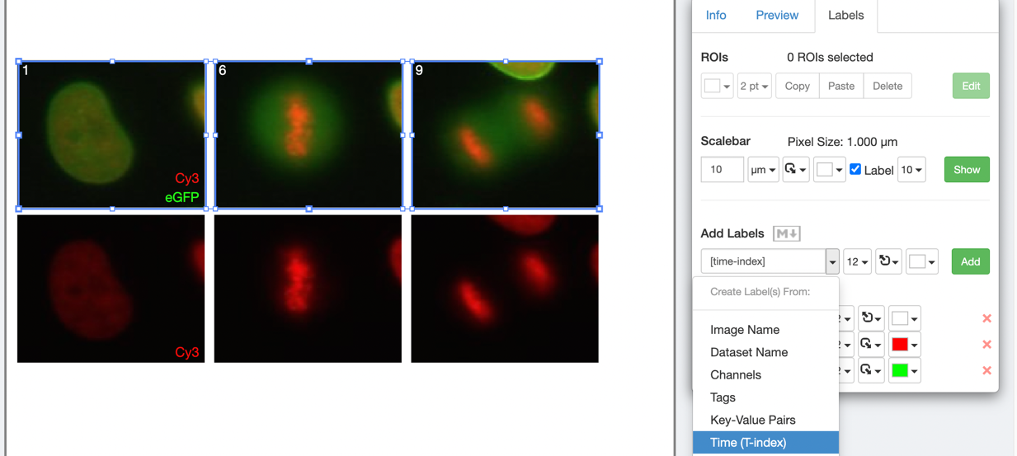

Step 6: Click *Save* to save your figure. To export your figure as PDF, click the *Export PDF* button at the top-right of the screen and wait for the PDF to be created on the server and the *Download* button to appear. Click to download the PDF and import to a PDF editor. You can post-process the PDF in Inkscape or Adobe Illustrator/Photoshop for example.

Further reading

More information on using OMERO with Fiji and Python workflows is available in our [online knowledge articles](https://jax.service-now.com/jax?id=kb_article&sysparm_article=KB0010549).

For more information about OMERO, please see the [official OMERO user documentation](https://omero-guides.readthedocs.io/en/latest/).

If you have questions or comments, contact JAX’s [Research IT Imaging Applications](https://jacksonlaboratory.sharepoint.com/sites/ResearchIT/SitePages/Imaging-Applications.aspx) team.